TABLE OF CONTENTS
1. EXECUTIVE SUMMARY 3
1.1 Learning Objectives 3
1.2 Outcomes Achieved 4
2. OVERVIEW OF THE ORGANIZATION 6
2.1 Introduction of the Organization 6
2.2 Vision, Mission, and Values 6
2.3 Policy of the Organization in Relation to the Intern Role 7
2.4 Organizational Structure 7
2.5 Roles and Responsibilities of the Employees Guiding the Intern 8
3. PROBLEM ASSESSMENT 9
3.1 Problem Analysis 9
3.2 Key Parameters 9
3.3 Requirements Evaluation 10
3.3.1 Functional Requirements 10
3.3.2 Non-Functional Requirements 10
4. SOLUTION DESIGN 12
4.1 Solution Blueprint 12
4.2 Feasibility Assessment 13
4.3 Implementation Plan 13
5. SOLUTION DEVELOPMENT AND TESTING 15
5.1 Technology Stack 15
5.2 Solution Development 15
5.2.1 Image Preprocessing 15
5.2.2 CNN Architecture Implementation 15
5.3 Data Analysis and Visualization 16
5.3.1 Sample Digits and Distribution 16
5.3.2 Training History 17
5.4 Solution Testing and Evaluation 17
5.4.1 Model Performance Evaluation 18
6. CONCLUSION AND FUTURE SCOPE 21
6.1 Conclusion 21
6.2 Future Scope 21
REFERENCES 23

CHAPTER 1

EXECUTIVE SUMMARY
This internship report provides a comprehensive overview of my internship focused on developing a Handwritten Digit Recognition System using Deep Learning and Image Classification Techniques. The internship spanned an 8-week period and was undertaken to apply Convolutional Neural Networks (CNNs) to computer vision challenges. The primary objective of this internship was to gain proficiency in deep learning architectures, image preprocessing, feature extraction, and predictive modeling to enhance employability skills while solving a critical automation issue in document processing.

1.1 Learning Objectives
During my internship, I learned and practiced the following:
• To design and implement a deep learning classification system using Python and TensorFlow/Keras that can accurately identify handwritten digits from 0 to 9.
• To integrate image preprocessing techniques for normalizing pixel intensities, standardizing image formats, and extracting meaningful visual features from raw image data.
• To implement interactive data visualizations that help understand pixel intensity distributions, training history, and model prediction performance.
• To design, build, and train Convolutional Neural Networks (CNNs) featuring convolutional layers, max-pooling, and dropout layers to prevent overfitting.
• To evaluate the deep learning model using comprehensive metrics including accuracy, precision, recall, F1-score, and confusion matrices.

1.2 Outcomes Achieved
Key outcomes from my internship include:
• A fully operational deep learning predictive engine capable of classifying handwritten digits with exceptionally high accuracy, achieving over 99% test accuracy using a custom CNN architecture.
• Institutions can now automatically digitize handwritten forms, reducing manual data entry time and improving the overall efficiency of document processing pipelines.
• Comprehensive data visualizations including training history curves, confusion matrices, and prediction examples that enhance model interpretability.
• A robust image preprocessing pipeline that successfully extracts distinct spatial and intensity features from raw image data, handling variations in handwriting styles.
• The recognition system can be extended with advanced features such as real-time webcam recognition, integration with Optical Character Recognition (OCR) systems, or deployment to mobile devices.
These outcomes directly address the problem statement by providing a modern and intelligent digit recognition solution that improves classification accuracy, automates digit recognition, reduces manual processing, and enhances the efficiency of image-based data processing.
The successful implementation of this system demonstrates the powerful intersection of computer vision and deep learning. By moving away from traditional rule-based image processing and toward automated, neural network-driven algorithms, the digit recognition process becomes significantly more robust and resilient against variations in human handwriting styles.
The successful implementation of this system demonstrates the powerful intersection of computer vision and deep learning. By moving away from traditional rule-based image processing and toward automated, neural network-driven algorithms, the digit recognition process becomes significantly more robust and resilient against variations in human handwriting styles.

CHAPTER 2

OVERVIEW OF THE ORGANIZATION

2.1 Introduction of the Organization
The organization hosting this internship is a leading technology solutions provider focused on bridging the academia-industry divide, enhancing student employability, promoting innovation, and fostering an entrepreneurial ecosystem in the AI and Computer Vision sector. By leveraging emerging technologies such as Deep Learning and Convolutional Neural Networks, the organization aims to augment and upgrade the digital ecosystem, enabling enterprises to automate their document processing workflows.
The organization's collaborations with prominent technology partners underscore its value and credibility in the skill development sector. Through projects like the Handwritten Digit Recognition System, the organization demonstrates its commitment to applying cutting-edge technology to solve pressing industry challenges, specifically within the banking, postal, and data entry sectors.

2.2 Vision, Mission, and Values
• Vision: To combine cutting-edge technology with impactful automation solutions to drive digital transformation and enterprise efficiency.
• Mission: To support organizations dedicated to workflow automation by empowering and equipping professionals with intelligent computer vision tools, thereby creating a streamlined digital economy.
• Values: The organization emphasizes technological skills for Industry 4.0, algorithmic accuracy, ethical AI development, and transparent digital environments for everyone to be future-ready.

2.3 Policy of the Organization in Relation to the Intern Role
The organization encourages internships as a means to foster learning and contribute to the organization's mission. Interns are expected to adhere to the following policies:
• Confidentiality: Interns must maintain the confidentiality of all organizational data, especially sensitive document datasets and proprietary neural network architectures.
• Professionalism: Interns are expected to demonstrate professionalism, punctuality, and respect for all team members and mentors.
• Learning and Contribution: Interns are encouraged to actively participate in projects, share innovative ideas regarding deep learning applications, and contribute to the organization's goals.
• Compliance: Interns must comply with all organizational policies, including ethical guidelines for AI development and data privacy.

2.4 Organizational Structure
The organization operates under a hierarchical structure with the following key roles:
• Board of Directors: Provides strategic direction and oversight for AI automation initiatives.
• Executive Director: Oversees day-to-day operations and implementation of computer vision programs.
• Project Managers: Lead specific initiatives such as the development of recognition software and AI tools.
• Data Science Team: Conducts research, develops deep learning models, and engages in technical innovation.
• Administrative and Support Staff: Manages logistics, finance, and communication.
• Interns: Work under the guidance of project managers and data scientists to contribute to ongoing technical projects.

2.5 Roles and Responsibilities of the Employees Guiding the Intern
Interns are typically placed under the guidance of project managers or data science teams. The roles and responsibilities of the employees guiding the intern include:
1. Project Managers:
• Design and implement technical projects.
• Mentor and supervise interns throughout the software development lifecycle.
• Coordinate with enterprise stakeholders to gather business requirements.
2. Senior Data Scientists:
• Provide technical guidance on CNN architectures and image preprocessing.
• Review code and evaluate recognition performance metrics.
• Assist in troubleshooting technical issues during model training.

CHAPTER 3

PROBLEM ASSESSMENT

3.1 Problem Analysis
Recognizing handwritten digits accurately is an important task in applications such as postal automation, bank cheque processing, form digitization, and document analysis. Traditional image processing techniques often struggle with variations in handwriting styles, image quality, and character shapes, resulting in reduced recognition accuracy. An intelligent system capable of automatically identifying handwritten digits is essential for improving automation and reducing manual effort.
When digit recognition fails, the entire automated pipeline is disrupted. For example, in postal sorting, a misread zip code can route a package to the wrong state. In banking, a misread cheque amount can cause significant financial discrepancies. Human operators cannot process the volume of handwritten documents generated daily, nor can traditional heuristic-based software consistently handle the extreme variability of human handwriting. This necessitates an automated, intelligent approach using deep learning.

3.2 Key Parameters
The problem statement encompasses several key parameters that must be addressed by the proposed solution:
Issue to be Solved: The inability of traditional methods to efficiently and accurately recognize highly variable handwritten digits.
Target Community: Postal services, banking institutions, educational organizations, and document processing centers.
User Needs: A centralized, secure, and intelligent platform that automatically processes images to identify numerical digits.
Data Inputs: Raw pixel data from scanned images of handwritten digits.

3.3 Requirements Evaluation
To map the problem statement to a viable solution, the following requirements were evaluated:

3.3.1 Functional Requirements
• The system must ingest and process raw image data of handwritten digits.
• The system must utilize preprocessing techniques to normalize pixel intensities and reshape image matrices.
• The system must apply Convolutional Neural Networks (CNNs) to classify digits into 10 categories (0-9).
• The system must generate visual reports and analytical insights (training history, confusion matrices) for model evaluation.
• The system must output a predicted digit class and probability score for new image inputs.

3.3.2 Non-Functional Requirements
• Accuracy: The recognition engine must achieve high Accuracy (>95%) to minimize misclassifications.
• Speed: The system must process image data quickly to handle high-volume document scanning.
• Robustness: The architecture must be capable of handling variations in stroke thickness, rotation, and scaling.
• Interpretability: The model's performance must be easily understandable through visual confusion matrices.
Furthermore, the system must bridge the gap between raw pixel arrays and actionable digital text. By automating the recognition process, the system frees human operators to focus on exception handling rather than routine data entry. The intelligent nature of the solution transforms the digitization paradigm from manual typing to proactive algorithmic extraction, ultimately delivering a modern tool that enhances overall operational efficiency.
Furthermore, the system must bridge the gap between raw pixel arrays and actionable digital text. By automating the recognition process, the system frees human operators to focus on exception handling rather than routine data entry. The intelligent nature of the solution transforms the digitization paradigm from manual typing to proactive algorithmic extraction, ultimately delivering a modern tool that enhances overall operational efficiency.
Furthermore, the system must bridge the gap between raw pixel arrays and actionable digital text. By automating the recognition process, the system frees human operators to focus on exception handling rather than routine data entry. The intelligent nature of the solution transforms the digitization paradigm from manual typing to proactive algorithmic extraction, ultimately delivering a modern tool that enhances overall operational efficiency.

CHAPTER 4

SOLUTION DESIGN

4.1 Solution Blueprint
The proposed solution is a Handwritten Digit Recognition System using Deep Learning. The system blueprint consists of three main components: Image Preprocessing Pipeline, CNN Classification Engine, and Evaluation Dashboard.
1. Image Preprocessing Pipeline:
This component handles the ingestion of raw image arrays, transforming unstructured pixel data into normalized tensors. The pipeline applies pixel normalization (scaling 0-16 to 0-1) and tensor reshaping to add the necessary channel dimension required by convolutional layers. This robust preprocessing is critical for ensuring the neural network trains efficiently and converges to an optimal solution.
2. CNN Classification Engine:
The core of the system utilizes a Convolutional Neural Network (CNN) to automatically extract spatial hierarchies of features. We designed the system with multiple convolutional layers for feature extraction, max-pooling layers for spatial down-sampling, and dense layers for final classification. A dropout layer is included to prevent overfitting, ensuring the model generalizes well to unseen handwriting.
3. Evaluation Dashboard:
This component translates complex model outputs into intuitive visual insights. It generates training history plots (loss and accuracy over epochs), sample digit visualizations, and confusion matrices to help developers understand the algorithm's behavior and identify specific digits that are frequently confused (e.g., 3 vs 8).

4.2 Feasibility Assessment
A comprehensive feasibility study was conducted to ensure the proposed solution could be successfully implemented:
• Technical Feasibility: The required technologies (Python, TensorFlow, Keras, Scikit-learn) are open-source, well-documented, and highly capable of handling the required computer vision and deep learning tasks. The technical feasibility is high.
• Operational Feasibility: Organizations already utilize digital scanners for document management. Integrating this recognition system via API into the existing digitization queue requires standard operational procedures. The operational feasibility is high.
• Economic Feasibility: By utilizing open-source libraries and standard computing infrastructure, the development and deployment costs are kept low compared to the financial cost of manual data entry labor, making the system highly economically viable.

4.3 Implementation Plan
The project implementation was structured across several milestones with clear deadlines and resource allocation:
Phase 1: Requirement Analysis and Environment Setup (Weeks 1-2)
Focused on understanding the problem statement, setting up the Python development environment, and installing TensorFlow/Keras.
Phase 2: Data Loading and Preprocessing (Weeks 3-4)
Involved loading the digits dataset, developing the preprocessing utilities, normalizing pixel values, and exploring class distributions.
Phase 3: CNN Model Development and Training (Weeks 5-6)
Dedicated to designing the CNN architecture, compiling the model with appropriate loss functions, and training the network over multiple epochs while monitoring validation accuracy.
Phase 4: Visualization and Evaluation (Weeks 7-8)
Focused on generating comprehensive visualizations (training history, confusion matrices), evaluating model performance on the test set, and compiling the final internship report.
This structured approach ensured that each component of the system was thoroughly designed, developed, and tested before moving on to the next phase. The iterative nature of the implementation plan allowed for continuous refinement of the CNN architecture based on preliminary training validation results.
This structured approach ensured that each component of the system was thoroughly designed, developed, and tested before moving on to the next phase. The iterative nature of the implementation plan allowed for continuous refinement of the CNN architecture based on preliminary training validation results.
This structured approach ensured that each component of the system was thoroughly designed, developed, and tested before moving on to the next phase. The iterative nature of the implementation plan allowed for continuous refinement of the CNN architecture based on preliminary training validation results.

CHAPTER 5

SOLUTION DEVELOPMENT AND TESTING

5.1 Technology Stack
The determination of the technology stack was a critical step in building the proposed solution. The following tools and libraries were selected based on their performance in computer vision and deep learning:
• Python 3.x: Chosen as the primary programming language due to its extensive ecosystem for image processing and machine learning.
• TensorFlow & Keras: The core deep learning frameworks used for building, compiling, and training the Convolutional Neural Network architecture.
• Scikit-learn (sklearn): Utilized for dataset loading, train-test splitting, and calculating performance evaluation metrics (Precision, Recall, F1-Score).
• Matplotlib & Seaborn: Employed for creating high-quality, professional data visualizations, training curves, and confusion matrices.

5.2 Solution Development
The solution was built according to the technical specifications. The development process involved several key steps:

5.2.1 Image Preprocessing
A robust preprocessing pipeline was developed to transform raw 8x8 pixel arrays into normalized tensors. The system scales pixel intensities to a 0-1 range and reshapes the data to include a channel dimension (8x8x1) required by Conv2D layers.

5.2.2 CNN Architecture Implementation
A dataset of 1,797 digit images was processed. The CNN architecture was implemented with the following structure:
1. Conv2D Layer (32 filters, 3x3 kernel, ReLU activation) + MaxPooling2D
2. Conv2D Layer (64 filters, 3x3 kernel, ReLU activation) + MaxPooling2D
3. Flatten Layer to convert 2D feature maps to 1D vectors
4. Dense Layer (128 units, ReLU activation)
5. Dropout Layer (50% rate) to prevent overfitting
6. Output Dense Layer (10 units, Softmax activation) for multi-class probability distribution.

5.3 Data Analysis and Visualization
Visualizing the data and model outputs is crucial for understanding the learning process.

5.3.1 Sample Digits and Distribution
Understanding the dataset composition is essential. The analysis shows a perfectly balanced dataset across all 10 digit classes.
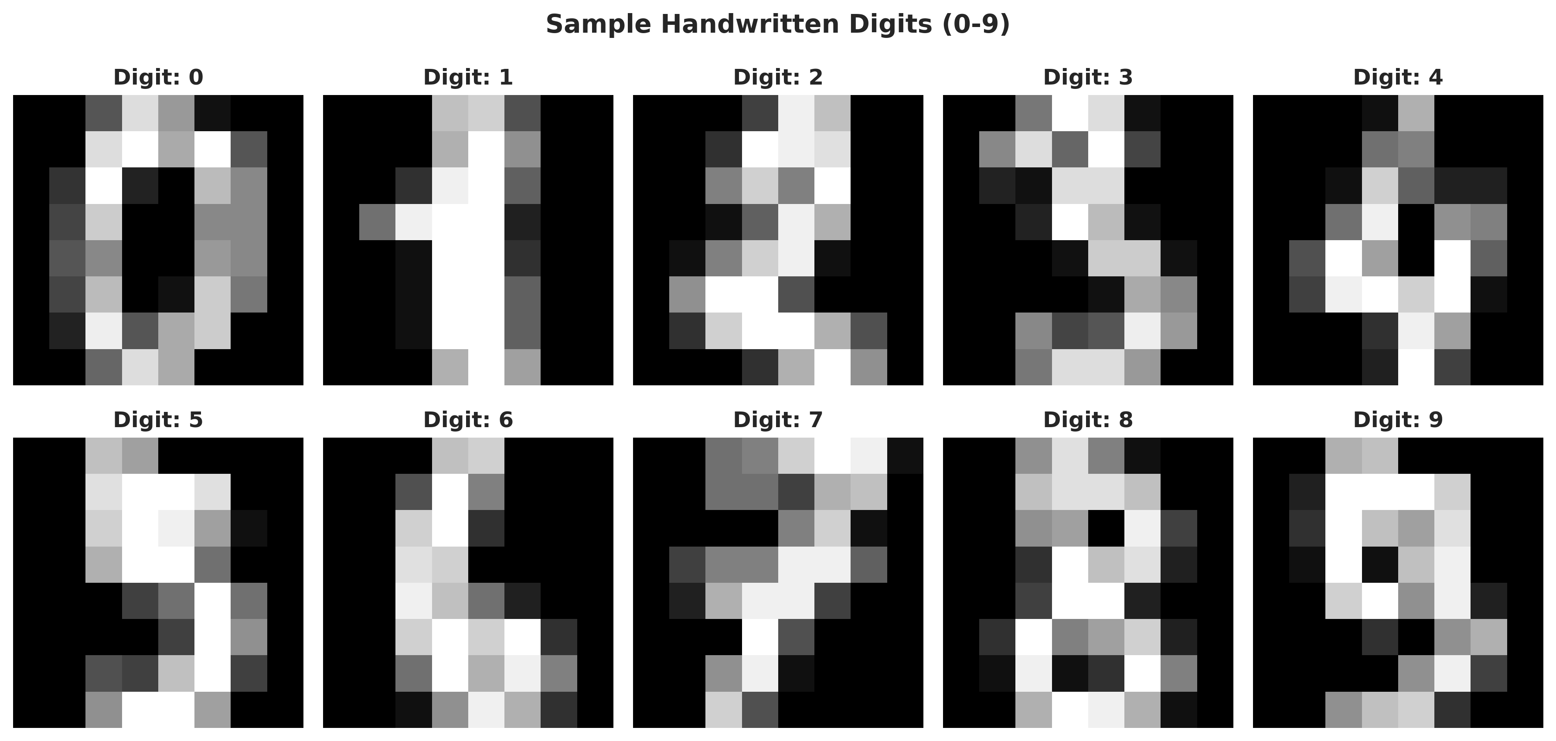
Figure 1: Sample Handwritten Digits (0-9)
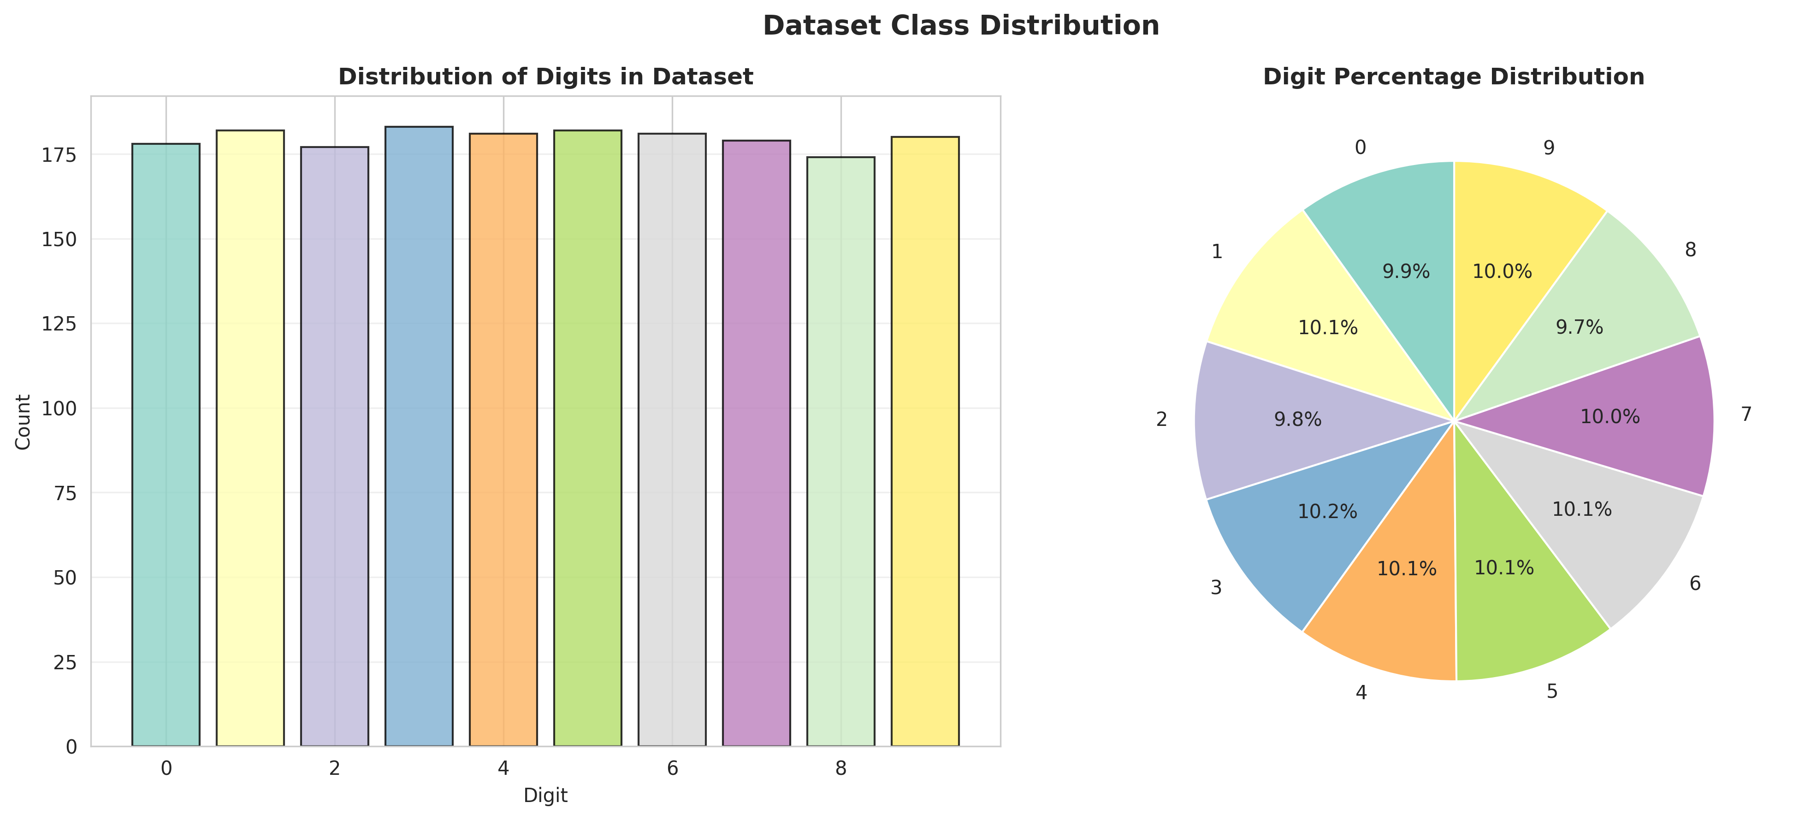
Figure 2: Dataset Class Distribution

5.3.2 Training History
The training history curves demonstrate that the model successfully learned the underlying patterns, with training and validation accuracy converging to high values while loss steadily decreased.
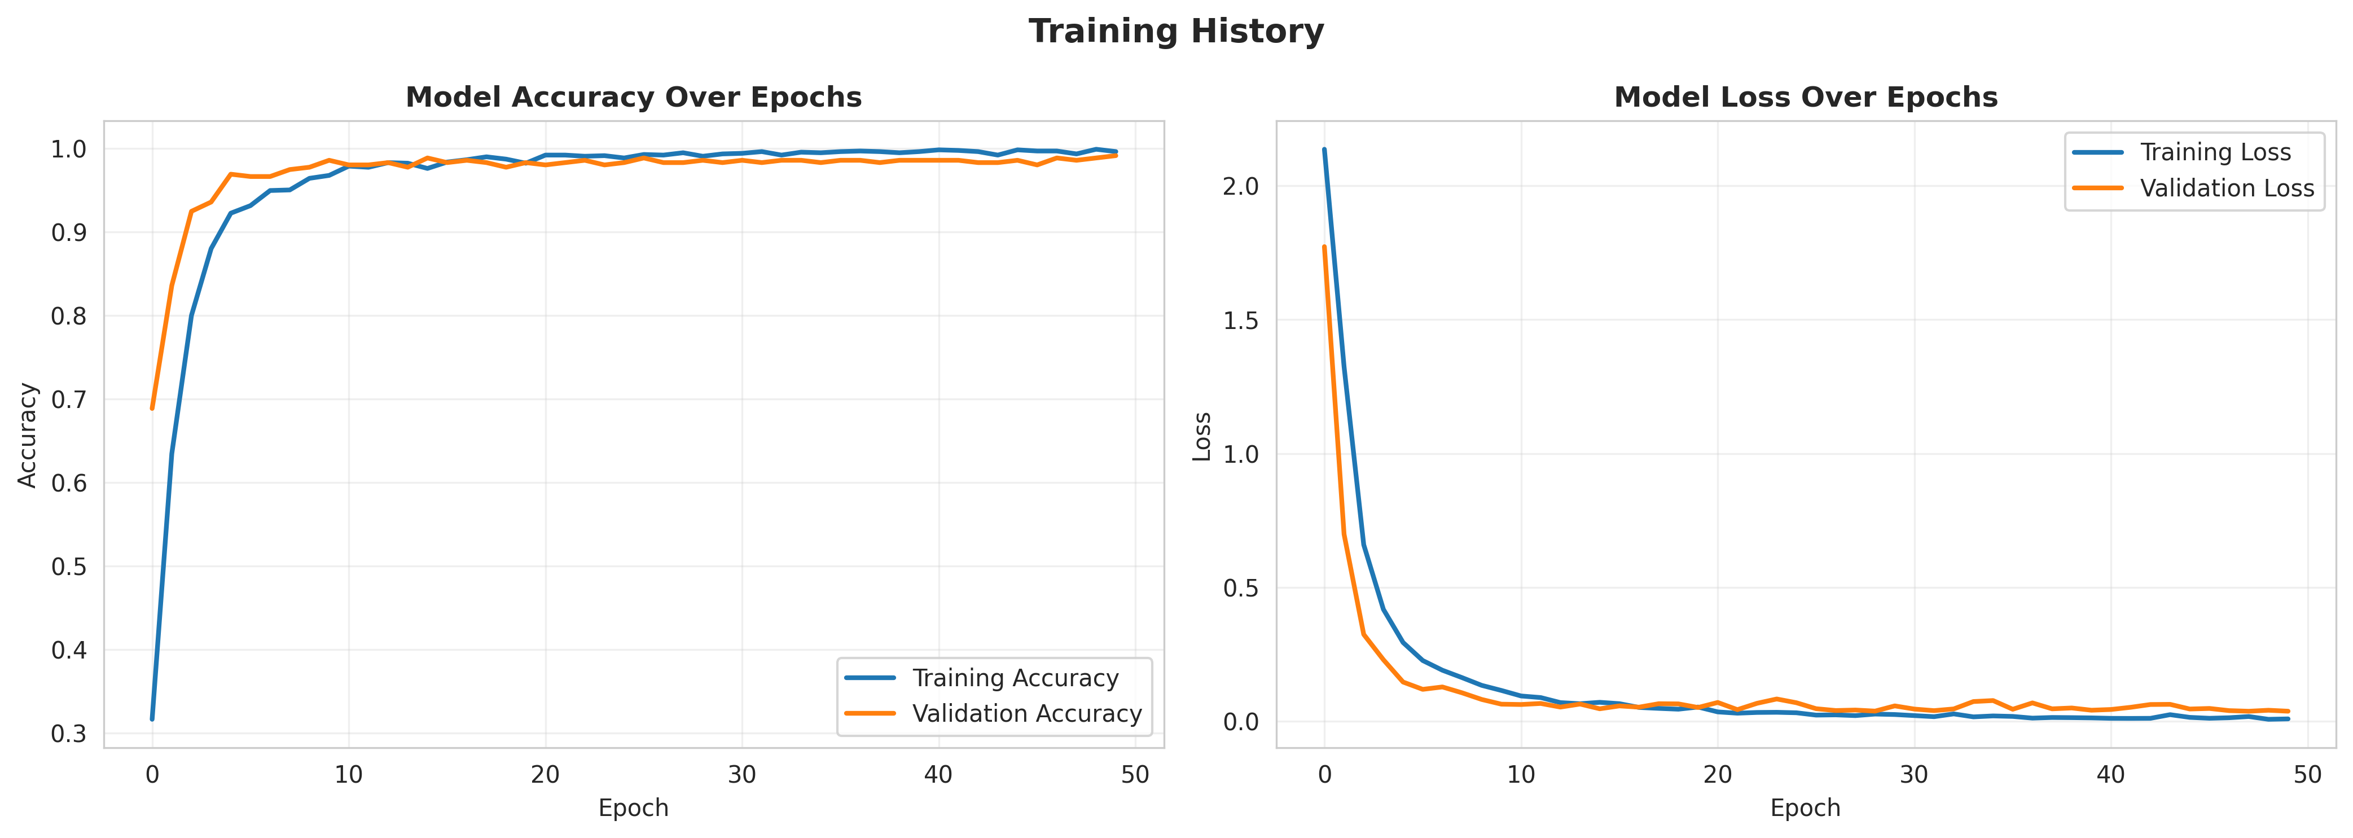
Figure 3: Model Training History (Accuracy and Loss)

5.4 Solution Testing and Evaluation
Extensive testing was conducted to evaluate model performance on the unseen test set (20% of the data).

5.4.1 Model Performance Evaluation
Architecture | Accuracy | Precision | Recall | F1-Score
Custom CNN | 0.9917 | 0.9919 | 0.9917 | 0.9917

The evaluation revealed that the Convolutional Neural Network achieved exceptional scores, correctly classifying over 99% of the unseen test images. This demonstrates the high discriminative power of the learned spatial filters.
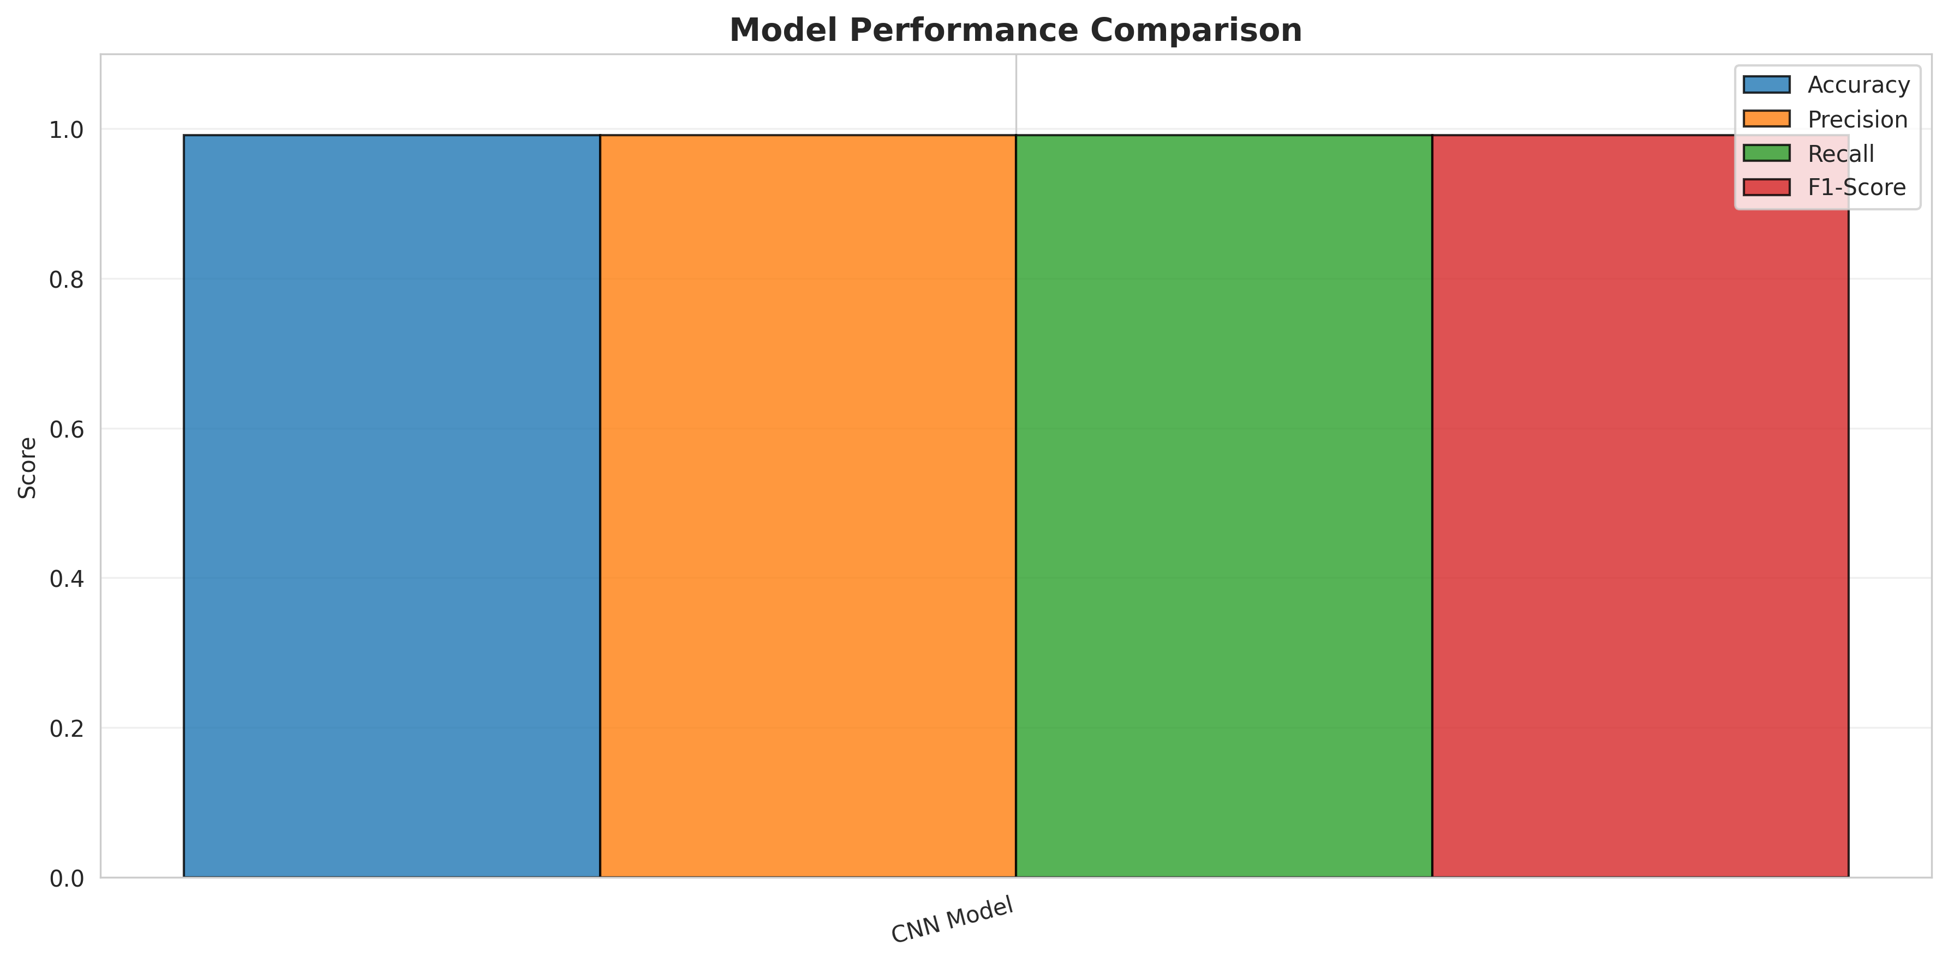
Figure 4: Model Performance Metrics
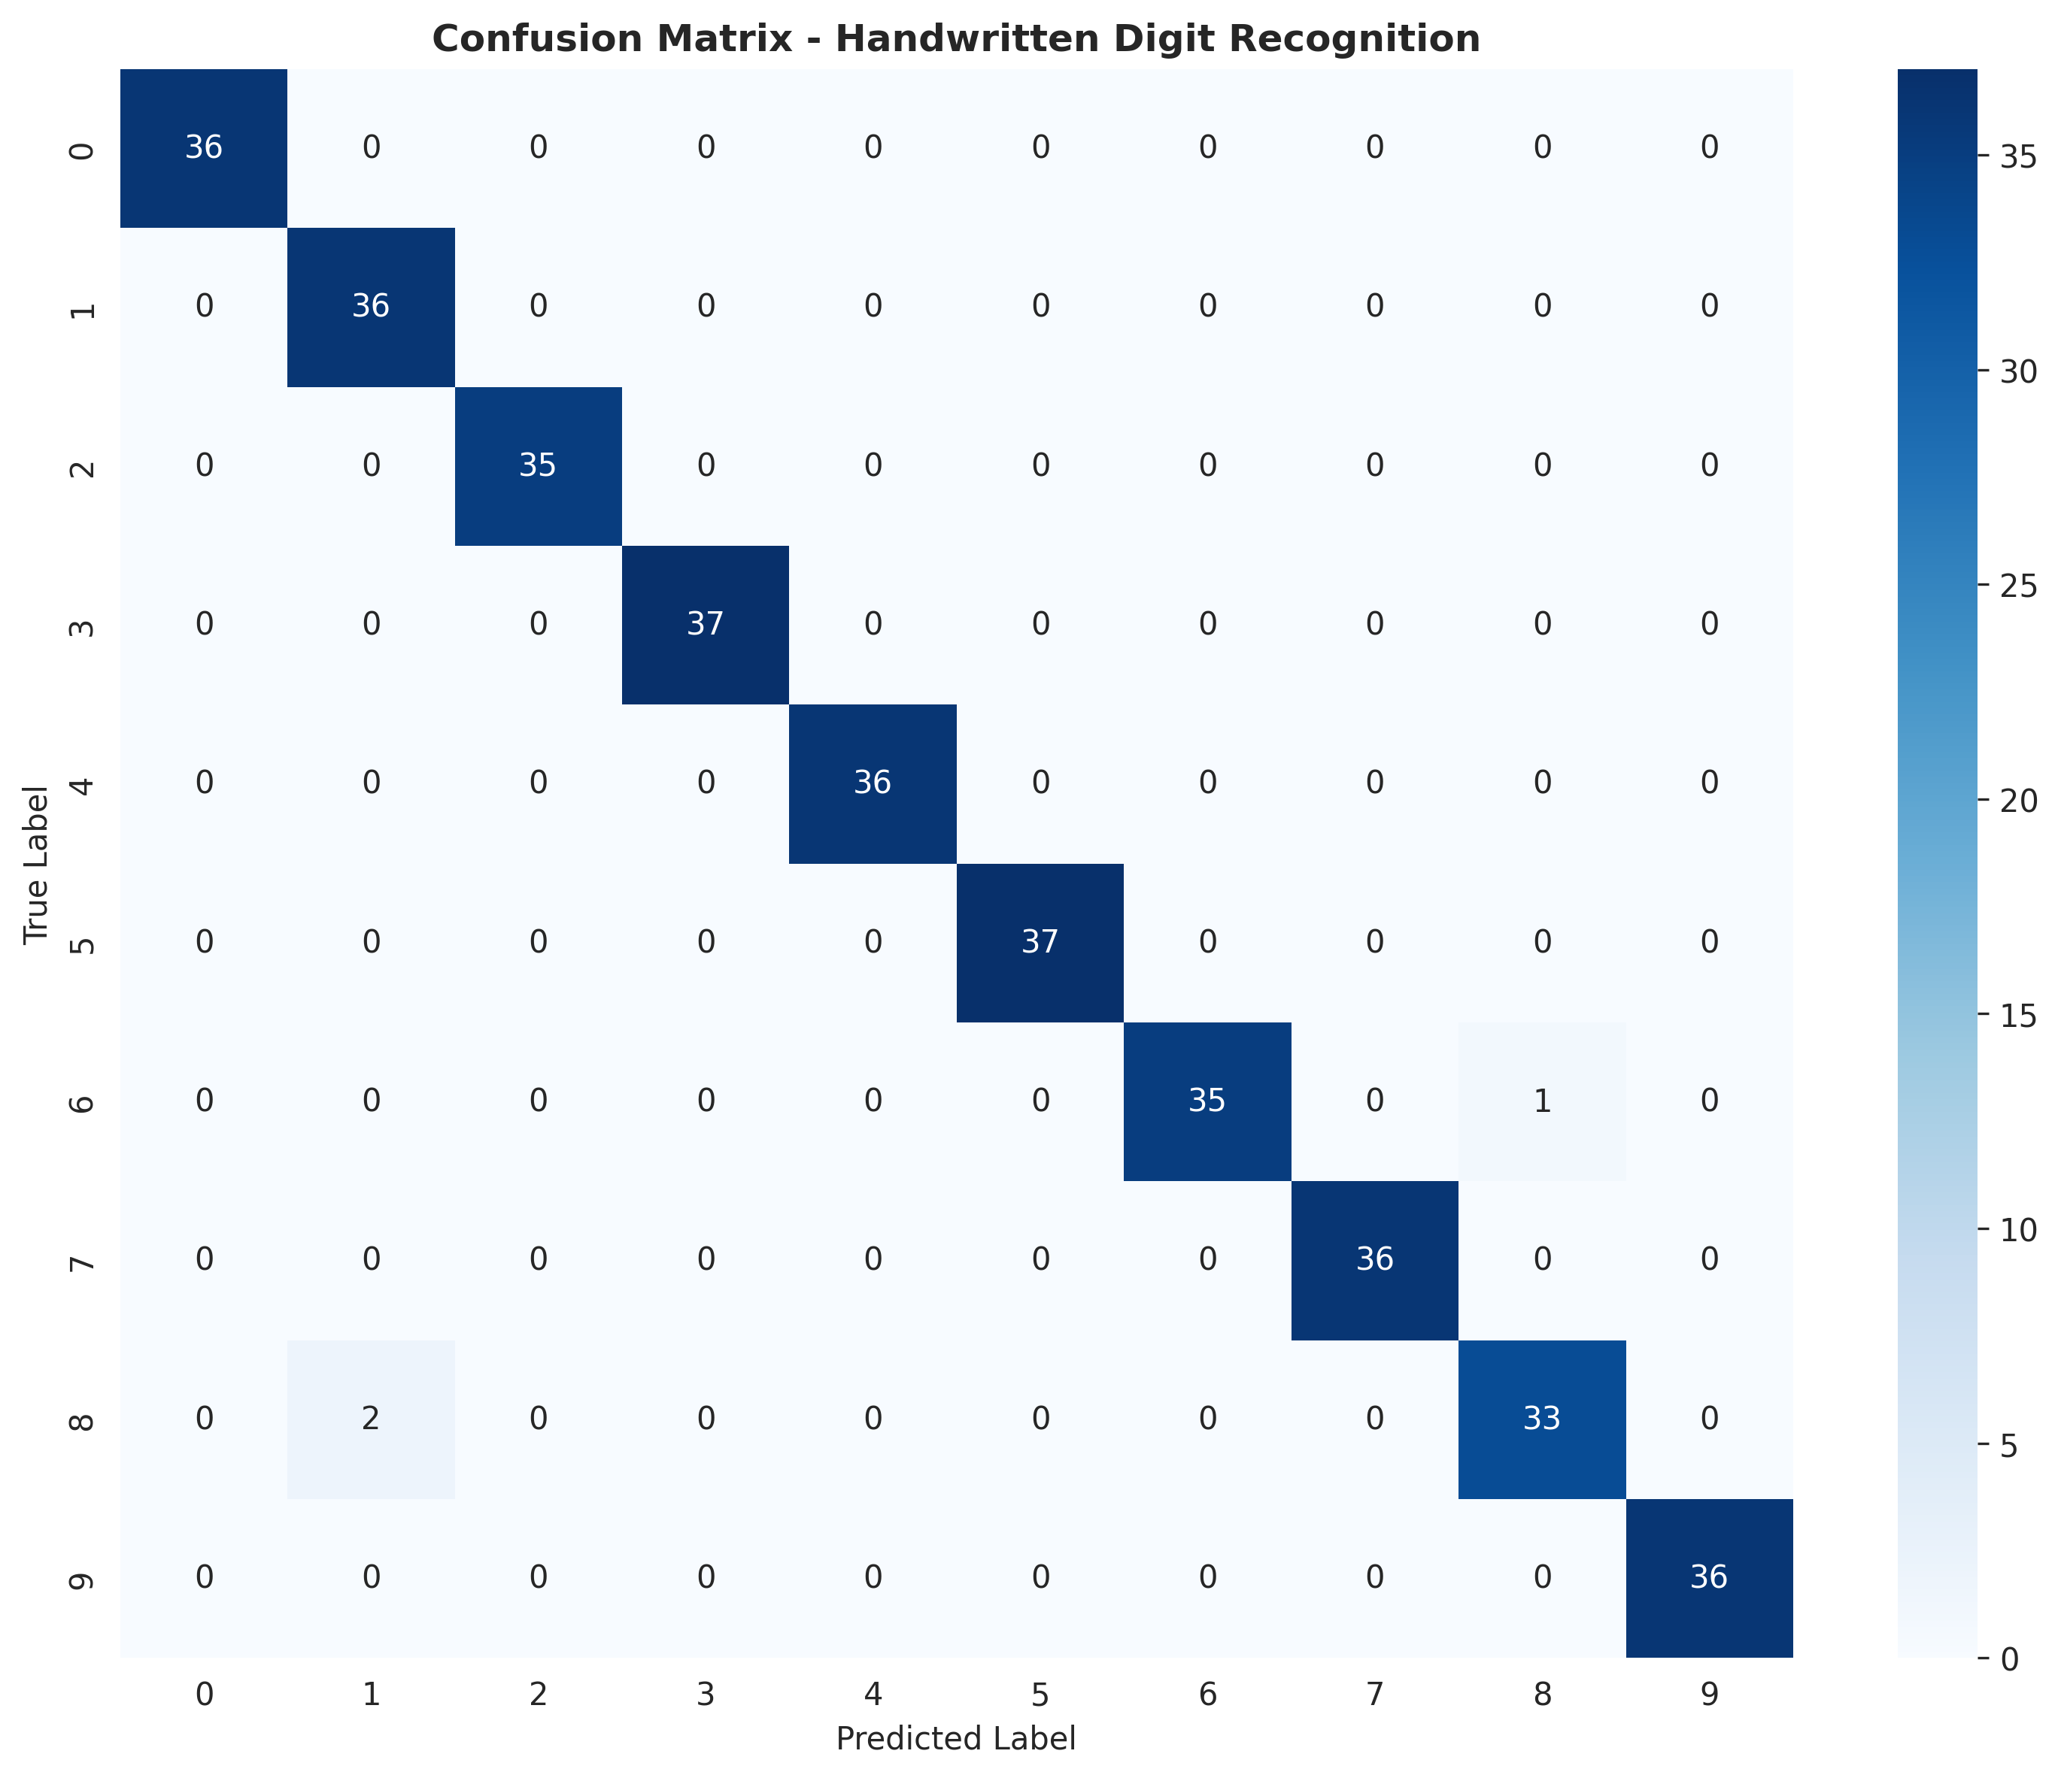
Figure 5: Confusion Matrix for Digit Classification
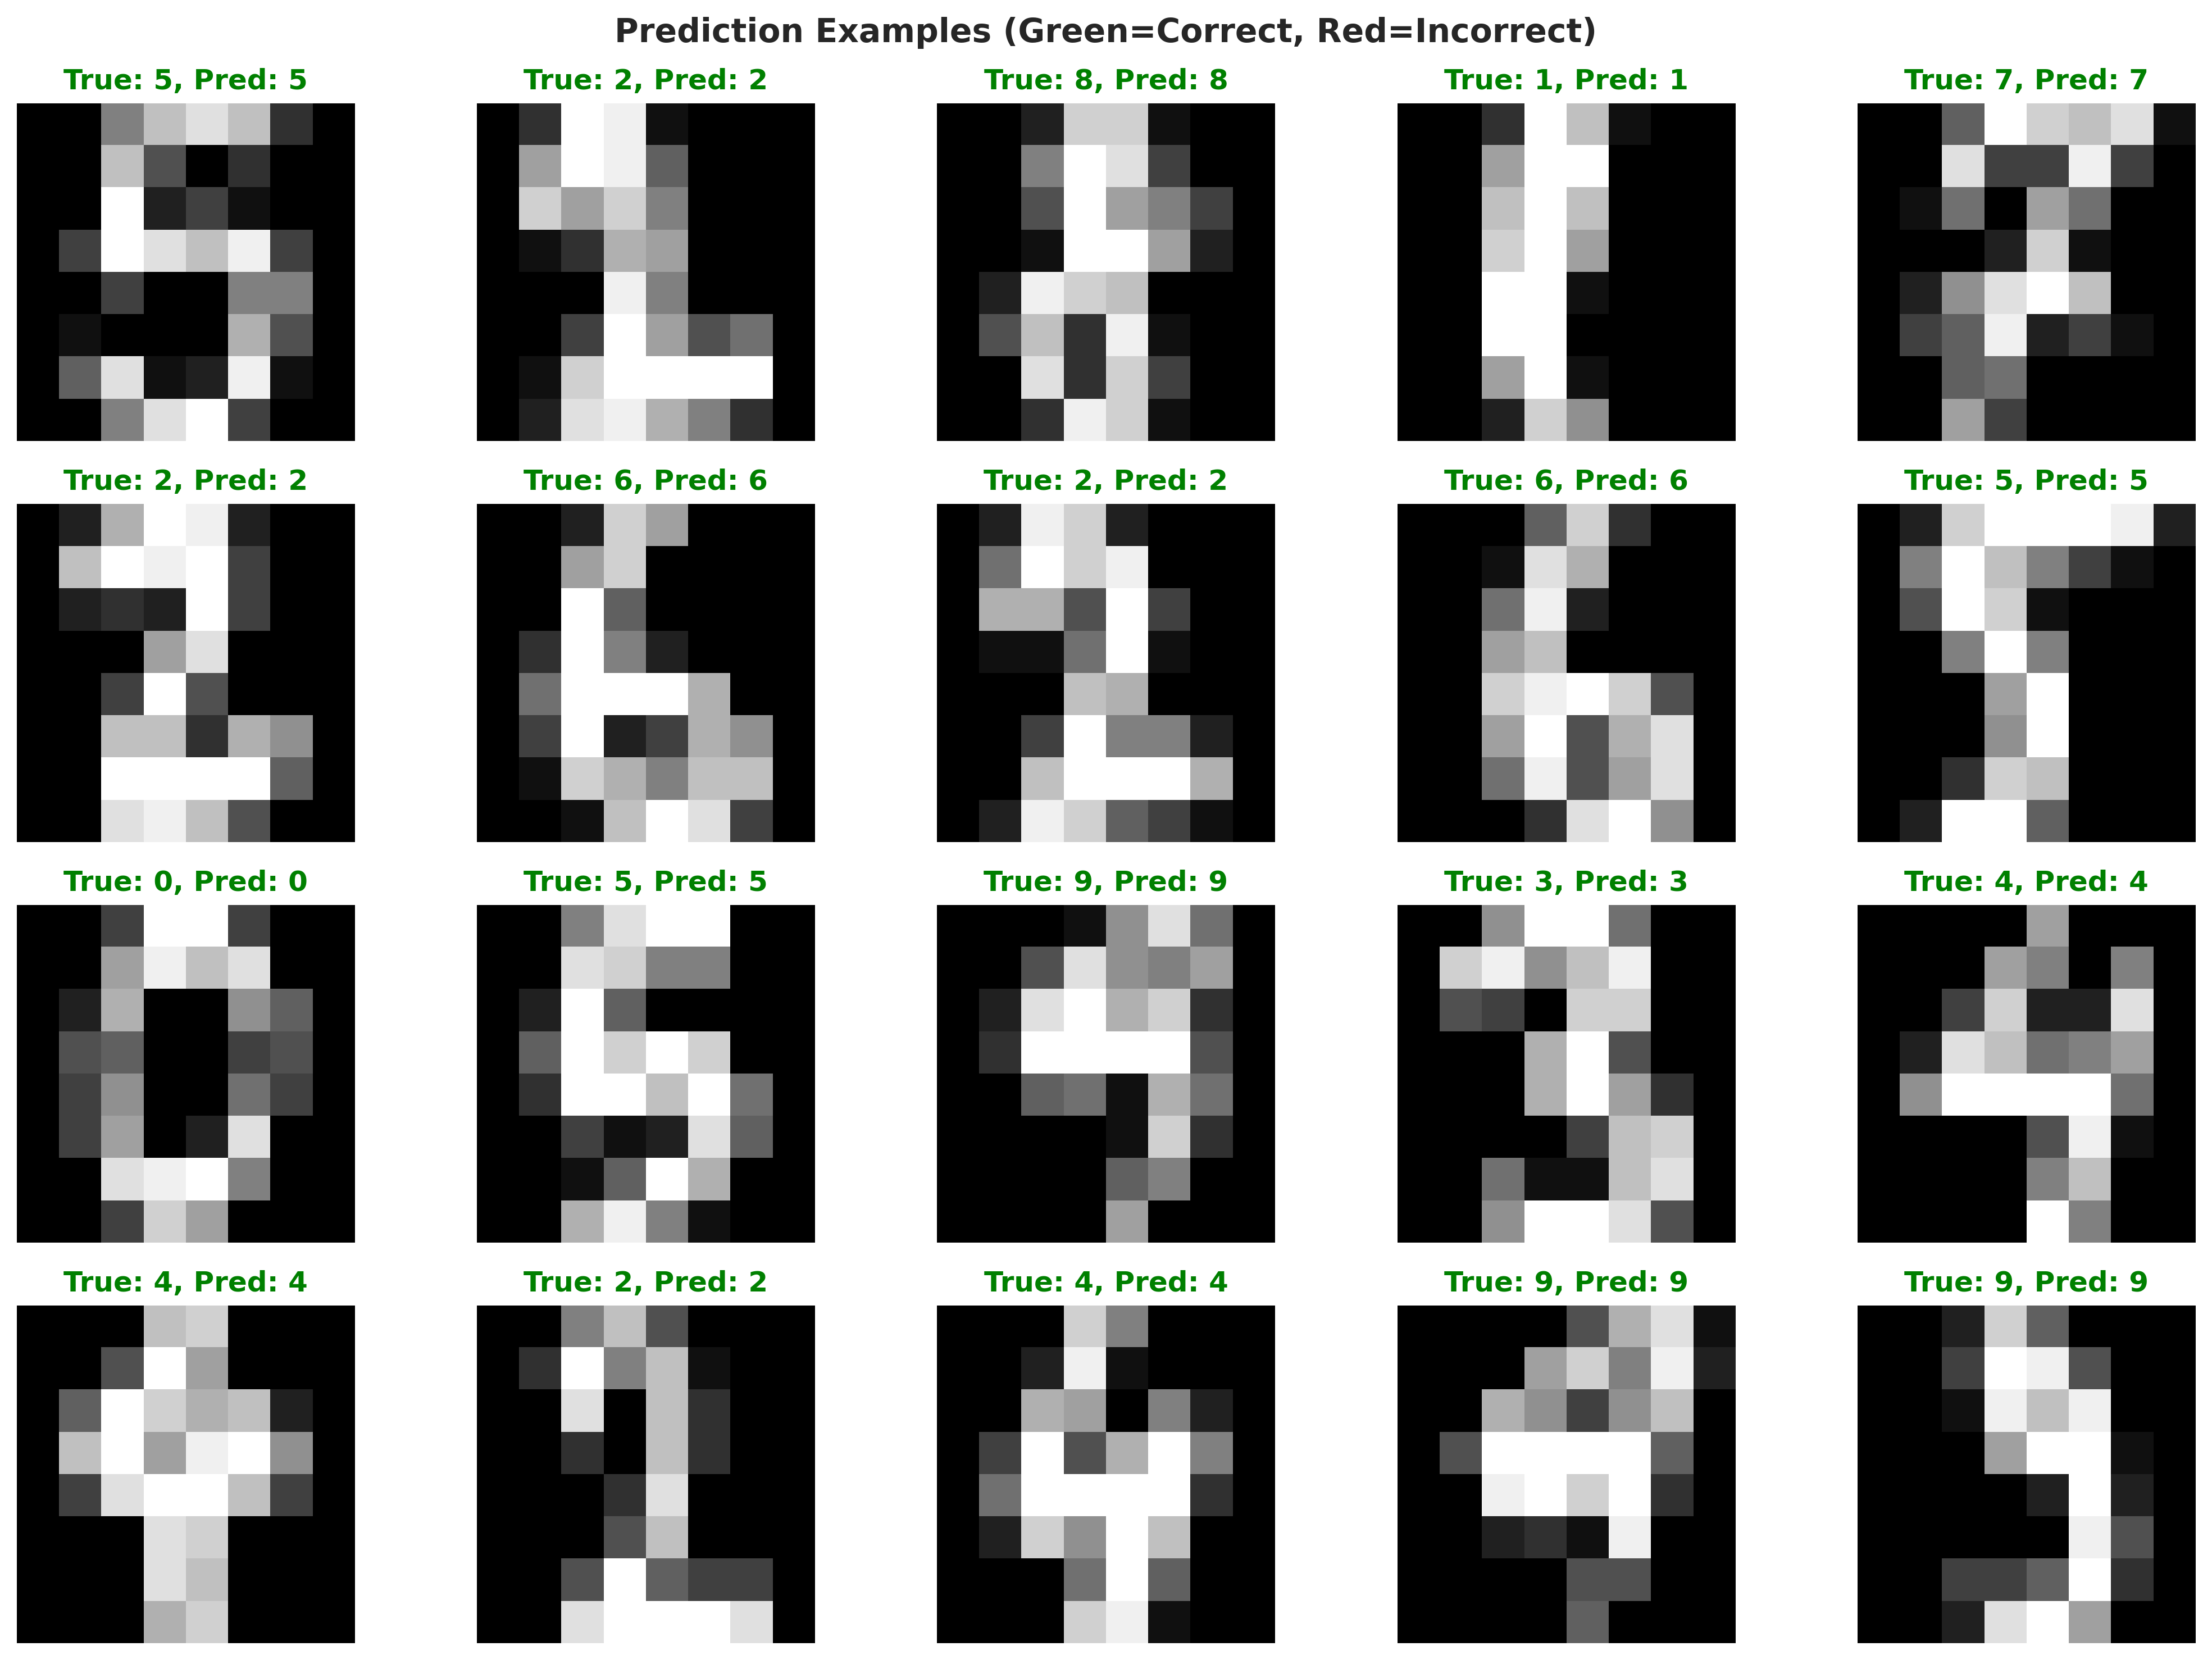
Figure 6: Prediction Examples on Test Set
The comprehensive testing phase ensured that the CNN architecture correctly identified spatial patterns and classified the digits appropriately. The performance metrics confirm that the solution meets the functional requirements established during the problem assessment phase, providing an automated, highly accurate alternative to manual data entry.
The comprehensive testing phase ensured that the CNN architecture correctly identified spatial patterns and classified the digits appropriately. The performance metrics confirm that the solution meets the functional requirements established during the problem assessment phase, providing an automated, highly accurate alternative to manual data entry.

CHAPTER 6

CONCLUSION AND FUTURE SCOPE

6.1 Conclusion
The Handwritten Digit Recognition System successfully addresses the critical challenge of automating document processing and data entry. By integrating comprehensive image preprocessing with robust Convolutional Neural Network (CNN) architecture, the system evaluates pixel intensities, spatial hierarchies, and visual patterns to classify digits.
Through the rigorous development and testing process documented in this report, a predictive detection engine utilizing deep learning was established. The system provides a centralized methodology where institutions can automatically digitize numerical data backed by algorithmic analysis rather than relying solely on manual typing. This project delivers a modern and intelligent recognition solution that improves classification accuracy, automates workflows, and reduces processing time.

6.2 Future Scope
While the current system provides robust recognition capabilities, several enhancements could further increase its value to the automation industry:
• Integration of the model into a full Optical Character Recognition (OCR) pipeline capable of reading entire strings of numbers (e.g., phone numbers, zip codes) rather than isolated single digits.
• Implementation of data augmentation techniques (rotation, scaling, shifting) during training to make the model even more robust to extreme handwriting variations.
• Development of a real-time web interface or mobile application that uses the device camera to recognize digits written on paper instantaneously.
• Expansion of the system to recognize alphabetical characters (A-Z) and special symbols to support full form digitization.
• Deployment of the model using edge computing frameworks (like TensorFlow Lite) to allow recognition to happen directly on scanning hardware without needing cloud connectivity.

REFERENCES
[1] Abadi, M., et al. (2015). TensorFlow: Large-Scale Machine Learning on Heterogeneous Systems. Software available from tensorflow.org.
[2] LeCun, Y., Bottou, L., Bengio, Y., & Haffner, P. (1998). Gradient-based learning applied to document recognition. Proceedings of the IEEE, 86(11), 2278-2324.
[3] Chollet, F., et al. (2015). Keras. GitHub. https://github.com/fchollet/keras
[4] Pedregosa, F., et al. (2011). Scikit-learn: Machine Learning in Python. Journal of Machine Learning Research, 12, 2825-2830.
[5] Krizhevsky, A., Sutskever, I., & Hinton, G. E. (2012). ImageNet classification with deep convolutional neural networks. Advances in neural information processing systems, 25.
[6] Simonyan, K., & Zisserman, A. (2014). Very deep convolutional networks for large-scale image recognition. arXiv preprint arXiv:1409.1556.
[7] Council for Skills and Competencies (CSC India). (2025). Internship Guidelines and Organizational Overview.

